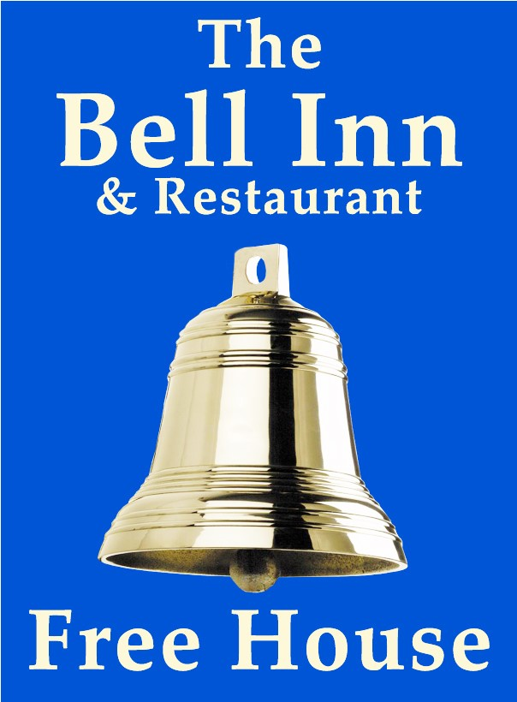
DRINKS
Fizzy Drinks
Elderflower Presse
Cawston Press Sparkling Apple
Pepsi Max
Diet Pepsi
Whites Lemonade
Coke
Frobisher’s Juices
Cloudy Apple
Cranberry
Pineapple
Mango
Tomato
Gins
Gordons
Hendricks
Bombay Sapphire
Ramsbury
Chase Pink Grapefruit
Rhubarb and Ginger
Gordons Pink
Real ales
Hop Union – Beau Bell 4.0% Best Bitter (GF)
A selection of guest ales – Please see the bar
Lagers
Lowenbrau 5.0%
Budvar 5.0%
Modelo 4.5%
Fever tree Mixers
Indian Tonic
Refreshingly Light Tonic
Elderflower Tonic
Ciders
Orchard Pig Reveller 4.5%
Lilleys Apple and Pear 4.0%
Lilleys Cherry and Berry 4.0% 500ml
Westons Vintage 5.0% Still
Rosies pig Rhubarb 4.0% Still
Low and No Alcohol
Sheppys Cider 500ml
Thatchers Zero
Heineken 0%
Gordons 0%
Guinness 0%
Draught Goram IPA

Kids Drinks
Fruit Shoot – Orange or Blackcurrant
Cawston Press – Apple and Pear or Apple and Mango
J20
Apple and Raspberry
Orange and Passionfruit

LUNCHTIME MENU
FULL MENU ALSO AVAILABLE

WARM SOFT BAGUETTE £13.50
White soft baguette served with salad and chips

Battered fish goujons with tartar sauce
Coronation chicken
Chicken and bacon mayo
Brie and red onion chutney (V)
Tuna Mayonnaise
Steak and melted stilton
Warm BBQ pulled pork

FILLED JACKET POTATOES £12.50
Your choice of filling, served with salad and coleslaw

Tuna Mayonnaise
Chicken and bacon mayo
Coronation chicken
Brie and red onion chutney (V)
Heinz beans and grated cheddar (V)
Warm BBQ pulled pork

FOR ALLERGEN AND FOOD INTOLERANCE INFORMATION PLEASE ASK A MEMBER OF STAFF

(V) Vegetarian (VE) Vegan

STARTERS

CRISPY DUCK SPRING ROLLs £8
Duck and shredded vegetables wrapped in filo pastry on a bed of salad drizzled in hoisin sauce

CRISPY GARLIC MUSHROOMS (V) £8
Breaded garlic mushrooms served with garlic mayo for dipping

CHILLI AND MANGO BREADED PRAWNS £8.75
King prawn butterflied, breaded and stuffed with chilli and mango served with salad and lemon mayo
MARINATED CHICKEN OR HALLOUMI FRIES £8.95
Choose one of the above, served in a honey BBQ sauce, on a bed of salad

BREADED BROCOLLI BITES (VE) £8
Served with sweet chilli mayonnaise

SALT AND PEPPER SQUID £8.25
Fried squid in a crispy coating with salad and lemon mayonnaise

SIDES
Sweet potato fries £5.95 Garlic bread £3.50 Fresh vegetables £ 3.50
Chips £5.50 Bread and butter £2.00 Mixed leaf salad £3.00
Cheesy chips £6.25 Cheesy garlic bread £3.75 Peas £2.50
New potatoes £3.50 Creamy mash £3.50 Coleslaw £3.00

(V) Vegetarian (VE) Vegan

MAIN COURSES
Smaller appetite portions available, please see items with 2 prices
Unless otherwise stated, all main courses are served with a choice of new potatoes, mash, chips, or sweet potato fries and your choice of fresh vegetables, salad or peas

BRIE AND BACON STUFFED BREAST OF CHICKEN £19
Chicken breast, stuffed with brie, wrapped in bacon and baked, served in a creamy mushroom sauce
BLADE OF BEEF £20/£16
Slow cooked in ale with mushrooms and onions topped with gravy on a bed of horseradish mash
FILLET OF SALMON £19
Grilled with a honey and ginger glaze
HOMEMADE PIE OF THE WEEK £19 /£15.50
A slice of shortcrust pie, served with gravy. Please ask for today’s filling
CHEESY COD FILLET £19/£15
Unbattered cod fillet smothered in melted cheddar
HAM “N” EGGS £17.50/14.50
Stiles ham with 2 fried eggs, chips and peas
SCAMPI £17.50/14.50
Breaded wholetail scampi served with chips, salad, peas and tartar sauce
BATTERED COD £18
Our own beer battered cod served with chips, peas and tartar sauce
PORK TENDERLOIN MEDALLIONS £19.95
Flamed in fortified wine, and cooked in an oregano and cream sauce
BEEF LASAGNE £17.50
Layers of bechamel sauce, minced meat and pasta, topped with melted cheddar served with salad
VEGETARIAN / VEGAN CHOICES
GOAT'S CHEESE TOPPED VEGETABLE NUT ROAST (V) £17.50
Served with your choice of chips and salad or new potatoes and vegetables
SPINACH AND RICOTTA CANNELLONI (V) £17.50
Pasta stuffed with spinach and ricotta in a tomato sauce served with salad
THREE BEAN CHILLI (VE) £17.50
Red Kidney, Black Turtle, and Cannellini Beans in a smoky BBQ chilli sauce served with rice
VEGAN LASAGNE(VE) £17.50
Served with mixed leaf salad
CHILDREN’S MENU
(smaller portions of adult meals available for bigger appetites, see meals with 2 prices)
4OZ MINUTE STEAK £10.95 BREADED CHICKEN GOUJONS £9.95
Served with onion rings, chips and peas served with chips and a side
WHOLETAIL SCAMPI £9.95 HAM “N” EGGS £9.95
Breaded scampi with tartare sauce Wiltshire ham and fried egg
VEGAN LASAGNE SERVED WITH SALAD £9.95

FROM THE GRILL
OUR BUTCHER IS STILES OF BROMHAM

10oz Sirloin steak (283g) £29.00
8oz Fillet steak (227g) £32.50
Weights are approximate before cooking
All steaks are served with grilled tomato, onion rings, chips and peas.
Add a sauce to your steak (served separate) £3.95
Pepper, Stilton or Mushroom
10oz Gammon – Served with fried egg, pineapple, chips and peas £17.95
Mixed grill £26.00
Mini steak, pork sausage, lamb chop, gammon and black pudding topped with a fried egg, served with chips, peas and grilled tomato

THE BELL SALADS £15
Mixed leaf salad with cucumber, cherry tomatoes, and coleslaw
Choose from balsamic or French dressing (served on the side)

Tuna mayonnaise with grated cheddar
Smoked salmon and prawns marie rose
Chicken and bacon mayo
Coronation chicken
Goats cheese in a honey and ginger glaze (V)
Crispy seafood (scampi, squid and fish goujons with lemon mayo)
Warm BBQ Pulled Pork

(V) Vegetarian (VE) Vegan
PUDDINGS
UNLESS STATED OUR PUDDINGS ARE SERVED WITH YOUR CHOICE OF CUSTARD, WHIPPED DOUBLE CREAM OR VANILLA ICE CREAM

HOMEMADE CHOCOLATE AND MINT CHEESECAKE £8.50
SHORTBREAD BASE WITH CHOCOLATE AND MINT TOPPING

HOMEMADE STICKY TOFFEE SPONGE PUDDING £8.95
A CLASSIC SPONGE PUDDING IN A RICH TOFFEE SAUCE

RASPBERRY AND LIMONCELLO TRIFLE £8
LEMON SPONGE SOAKED IN LIMONCELLO, RASPBERRIES, CUSTARD, TOPPED WITH CREAM

HOMEMADE WHITE CHOCOLATE AND LEMON CHEESECAKE £8.50
SHORTBREAD BASE WITH LEMON TOPPING

CHOCOLATE BROWNIE SUNDAE £8.50
CHUNKS OF RICH BROWNIE LAYERED WITH ICE-CREAM & CHOCOLATE SAUCE

VEGAN CHOCOLATE ORANGE SPONGE (VE) £8.50
CHOCOLATE AND ORANGE SPONGE WITH VEGAN ICE-CREAM

HAZELNUT CHOCOLATE SUNDAE £8.75
LAYERS OF CHOCOLATE SORBET, HAZELNUT ICE-CREAM WITH WHITE CHOCOLATE AND HAZELNUT SAUCE

MANGO ICECREAM SUNDAE £8
LAYERS OF MANGO, MANGO SORBET & VANILLA ICECREAM

RASPBERRY MERINGUE SUNDAE £8
LAYERS OF RASPBERRIES, VANILLA ICE-CREAM AND CRUSHED MERINGUE

LACOCK DAIRY ICECREAM/SORBET SELECTION £3 PER SCOOP

VANILLA, STRAWBERRY, CHOCOLATE, HONEYCOMB. SALTED CARAMEL, MINT CHOCOLATE, HAZELNUT PRALINE, VEGAN VANILLA
SORBETS – LEMON, MANGO, CHOCOLATE

HOT DRINKS

AMERICANO £3.95
SERVED WITH HOT OR COLD MILK ON THE SIDE

CAFÉ LATTE £4.15
DOUBLE SHOT OF ESPRESSO WITH STEAMED MILK

ESPRESSO £3.95
SINGLE SHOT OF ESPRESSO

DOUBLE ESPRESSO £4.15
DOUBLE SHOT OF ESPRESSO

FLAT WHITE £4.15
DOUBLE ESPRESSO WITH CREAMY MILK, STRONGER THAN LATTE

CAPPUCCINO £4.15
DOUBLE ESPRESSO WITH FROTHY MILK AND CHOCOLATE SPRINKLES

HOT CHOCOLATE £4.15
MADE WITH STEAMED MILK AND WATER FOR A CREAMY FEEL

LIQUER COFFEE £7.50
A SHOT OF YOUR CHOICE OF SPIRIT WITH AMERICANO AND SUGAR TOPPED WITH DOUBLE CREAM

LIQUER-LESS COFFEE £5.00
LARGE AMERICANO WITH SUGAR TOPPED WITH DOUBLE CREAM

TEA £3.50
POT OF TETLEY TEA

SPECIALITY TEA £3.95
CHOOSE FROM EARL GREY, PEPPERMINT, GREEN, CAMOMILE OR FRUIT

DECAF COFFEE £3.75
SERVED WITH HOT OR COLD MILK

OAT MILK AVAILABLE ON REQUEST

