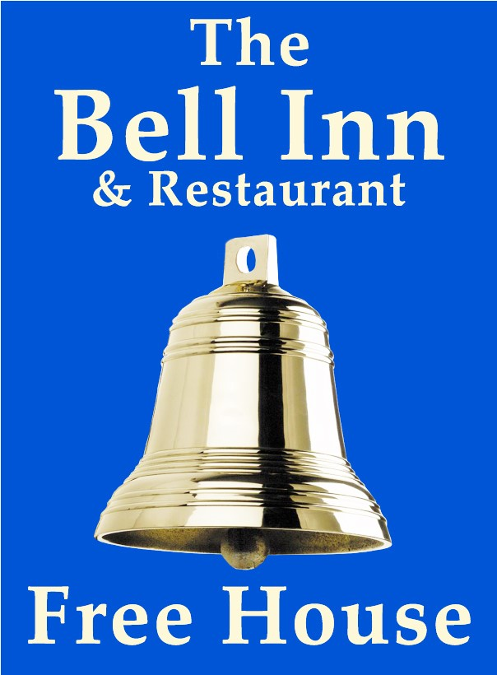
Paul, Georg and their team, warmly welcome you to The Bell. Our aim is to provide home cooked food, in a welcoming environment, with fantastic service.
We are a friendly team, if there is anything we can help you with please don’t hesitate to ask.
We hope you enjoy your visit.

- All meals are cooked to order and we endeavour to use the best fresh and local produce.
Our meat is supplied by Stiles of Bromham and our fresh vegetables by Heritage fine foods of Coate
- Dog are welcome in the bar, barn and garden areas. We please ask that they be kept on a lead and off the furniture at all times.
- Bookings are recommended. Please call 01249 730308.
- We are passionate about real ale and local beers and offer a great range of drinks for all tastes. Not sure what pint you want? You can always ask us for a taste.

- Owners : Paul and Georgia Maloney
- Management team: Fee, Trina, Ali, Toni, Tamara

LUNCHTIME MENU
FULL MENU ALSO AVAILABLE

WARM SOFT BAGUETTE £13.50
White soft baguette served with salad and chips

Battered fish goujons with tartar sauce
Coronation chicken
Chicken and bacon mayo
Brie and red onion chutney (V)
Tuna Mayonnaise
Steak and melted stilton

FILLED JACKET POTATOES £12.50
Your choice of filling, served with salad and coleslaw

Tuna Mayonnaise
Chicken and bacon mayo
Coronation chicken
Brie and red onion chutney (V)
Heinz beans and grated cheddar (V)

(V) Vegetarian

STARTERS

WARM BAKED BRIE (V) £8.75
Melted brie with a swirl of red onion chutney served with bread

CRISPY DUCK SPRING ROLLs £8.00
Duck and shredded vegetables wrapped in filo pastry on a bed of salad drizzled in hoisin sauce

CRISPY GARLIC MUSHROOMS (V) £8.00
Breaded garlic mushrooms served with garlic mayo for dipping

STICKY HOISIN HALLOUMI (V) £8.75
Warm strips of halloumi cheese glazed with sticky hoisin sauce served on a bed of mixed leaf salad topped with sesame seeds

SALT AND PEPPER SQUID £8.25
Fried squid in a crispy coating with salad and lemon mayonnaise

PRAWN SELECTION £8.75
Coconut breaded, Thai filo wrapped, nacho crumb, breaded butterflied served with a sweet Thai chilli sauce and salad
BONELESS MARINATED CHICKEN £8.75
Breaded chicken in this week’s special sauce served on a bed of salad

HOMEMADE SOUP OF THE DAY (V) £8.00
Please ask for today’s flavour- Served with bread

FOR ALLERGEN AND FOOD INTOLERANCE INFORMATION PLEASE ASK A MEMBER OF STAFF

(V) Vegetarian
BELL FAVOURITES
Smaller appetite portions available, please see items with 2 prices

All main courses are served with a choice of new potatoes, mash, chips, or sweet potato fries and your choice of fresh vegetables, salad or peas

BRIE AND BACON STUFFED BREAST OF CHICKEN £19
Chicken breast, stuffed with brie, wrapped in bacon and baked, served in a creamy mushroom sauce

BLADE OF BEEF £19/£15
Slow cooked in ale with mushrooms and onions topped with gravy on a bed of horseradish mash

FILLET OF SALMON £18
Grilled with a honey and ginger glaze

HOMEMADE FISH PIE £18
White and smoked fish, salmon and prawns in a leek and onion sauce, topped with creamy mash

HOMEMADE PIE OF THE WEEK £18.50/15.50
A slice of shortcrust pie, served with gravy
Please ask for today’s filling

HOMEMADE CASSEROLE OF THE WEEK £18.50/15.50
Please ask for today’s flavour

PORK TENDERLOIN MEDALLIONS £19.95
Flamed in fortified wine, and cooked in an oregano and cream sauce

CHEESY COD FILLET £18
Unbattered cod fillet smothered in melted cheddar

CLASSIC COMFORT FOOD
Smaller appetite portions available, please see items with 2 prices
HAM “N” EGGS £17.50/14.50
Stiles ham with fried eggs, chips and peas

SCAMPI £17.50/14.50 BATTERED COD £18
Breaded wholetail scampi served with chips, Our own beer battered cod served with
Salad, peas and tartar sauce Chips, peas and tartar sauce

VEGETARIAN CHOICES

GOAT'S CHEESE TOPPED VEGETABLE NUT ROAST £17.50
Served with your choice of chips and salad or new potatoes and vegetables

SPINACH AND RICOTTA CANNELLONI £17.50
Pasta stuffed with spinach and ricotta in a tomato sauce served with salad and chips

VEGAN CHOICES

THREE BEAN CHILLI £17.50
Red Kidney, Black Turtle, and Cannellini Beans in a smoky BBQ chilli sauce served with rice

VEGAN LASAGNE £17.50
Served with mixed leaf salad

CHILDREN'S MENU
(smaller portions of adult meals available for bigger appetites, see meals with 2 prices)
4OZ MINUTE STEAK £10.95 BREADED CHICKEN GOUJONS£9.95
Served with onion rings, chips and peas served with chips and a side
VEGAN LASAGNE SERVED WITH SALAD £9.95
WHOLETAIL SCAMPI £9.95 HAM “N” EGGS £9.95
Breaded scampi with tartare sauce Wiltshire ham and fried egg

FROM THE GRILL
OUR BUTCHER IS STILES OF BROMHAM

10oz Sirloin steak (283g) £29.00
8oz Fillet steak (227g) £32.50
Weights are approximate before cooking
All steaks are served with grilled tomato, onion rings, chips and peas.
Add a sauce to your steak (served separate)
Pepper, Stilton or Mushroom £3.95
10oz Gammon – Served with fried egg, pineapple, chips and peas£17.95
Mixed grill £26.00
Mini steak, pork sausage, lamb chop, gammon and black pudding topped with a fried egg, served with chips, peas and grilled tomato

THE BELL SALADS £15
Mixed leaf salad with cucumber, cherry tomatoes, and coleslaw
Choose from balsamic or French dressing (served on the side)

Tuna mayonnaise with grated cheddar
Smoked salmon and prawns marie rose
Chicken and bacon mayo
Coronation chicken
Goats cheese in a honey and ginger glaze (V)
Crispy seafood (scampi, squid and fish goujons with lemon mayo

SIDES
Sweet potato fries £5.95 Garlic bread £3.50 Fresh vegetables £ 3.50
Chips £5.25 Bread and butter £2.00 Mixed leaf salad £3.00
Cheesy chips £5.95 Cheesy garlic bread £3.75 Peas £2.50
New potatoes £3.50 Creamy mash £3.50 Coleslaw £3.00

(V) Vegetarian

PUDDINGS
UNLESS STATED OUR PUDDINGS ARE SERVED WITH YOUR CHOICE OF CUSTARD, WHIPPED DOUBLE CREAM OR VANILLA ICE CREAM

HOMEMADE CHOCOLATE AND MINT CHEESECAKE £8.50
SHORTBREAD BASE WITH CHOCOLATE AND MINT TOPPING

HOMEMADE STICKY TOFFEE SPONGE PUDDING £8.95
A CLASSIC SPONGE PUDDING IN A RICH TOFFEE SAUCE

RASPBERRY AND LIMONCELLO TRIFLE £8.00
LEMON SPONGE SOAKED IN LIMONCELLO, RASPBERRIES, CUSTARD, TOPPED WITH CREAM

HOMEMADE WHITE CHOCOLATE AND LEMON CHEESECAKE £8.50
SHORTBREAD BASE WITH LEMON TOPPING

CHOCOLATE BROWNIE SUNDAE £8.50
CHUNKS OF RICH BROWNIE LAYERED WITH ICE-CREAM & CHOCOLATE SAUCE

VEGAN CHOCOLATE ORANGE SPONGE £8.50
CHOCOLATE AND ORANGE SPONGE WITH VEGAN ICE-CREAM

HAZELNUT CHOCOLATE SUNDAE £8.75
LAYERS OF CHOCOLATE SORBET, HAZELNUT ICE-CREAM WITH WHITE CHOCOLATE AND HAZELNUT SAUCE

APPLE PIE £8.00
SHORTCRUST PASTRY WITH A BRAMLEY APPLE FILLING

MANGO ICECREAM SUNDAE £8.00
LAYERS OF MANGO, MANGO SORBET & VANILLA ICECREAM

RASPBERRY MERINGUE SUNDAE £8.00
LAYERS OF RASPBERRIES, VANILLA ICE-CREAM AND CRUSHED MERINGUE

ICECREAM/SORBET SELECTION £3 PER SCOOP

OUR ICE-CREAM IS SUPPLIED BY LACOCK DAIRY. PLEASE CHOOSE FROM THE FOLLOWING FLAVOURS – VANILLA, STRAWBERRY, CHOCOLATE, HONEYCOMB. SALTED CARAMEL, MINT CHOCOLATE, HAZELNUT PRALINE, VEGAN VANILLA
SORBETS – LEMON, MANGO, CHOCOLATE

HOT DRINKS

AMERICANO £3.75
SERVED WITH HOT OR COLD MILK ON THE SIDE

CAFÉ LATTE £3.95
DOUBLE SHOT OF ESPRESSO WITH STEAMED MILK

ESPRESSO £3.75
SINGLE SHOT OF ESPRESSO

DOUBLE ESPRESSO £3.95
DOUBLE SHOT OF ESPRESSO

FLAT WHITE £3.95
DOUBLE ESPRESSO WITH CREAMY MILK, STRONGER THAN LATTE

CAPPUCCINO £3.95
DOUBLE ESPRESSO WITH FROTHY MILK AND CHOCOLATE SPRINKLES

HOT CHOCOLATE £3.95
MADE WITH STEAMED MILK AND WATER FOR A CREAMY FEEL

LIQUER COFFEE £7.50
A SHOT OF YOUR CHOICE OF SPIRIT WITH AMERICANO AND SUGAR TOPPED WITH DOUBLE CREAM

LIQUER-LESS COFFEE £5.00
LARGE AMERICANO WITH SUGAR TOPPED WITH DOUBLE CREAM

TEA £3.50
POT OF TETLEY TEA

SPECIALITY TEA £3.75
CHOOSE FROM EARL GREY, PEPPERMINT, GREEN, CAMOMILE OR FRUIT

DECAF COFFEE £3.50
SERVED WITH HOT OR COLD MILK

OAT MILK AVAILABLE ON REQUEST

