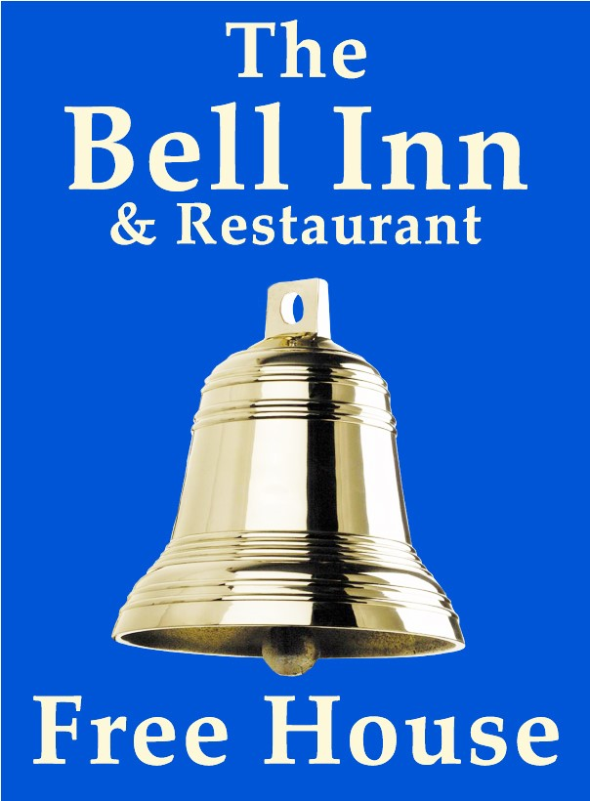Paul, Georg and their team, warmly welcome you to The Bell. Our aim is to provide home cooked food, in a welcoming environment, with fantastic service.

We are a friendly team, if there is anything we can help you with please don’t hesitate to ask.

We hope you enjoy your visit.

* All meals are cooked to order and we endeavour to use the best fresh and local produce.

Our meat is supplied by Stiles of Bromham and our fresh vegetables by Heritage fine foods of Coate

* Dog are welcome in the bar, barn and garden areas. We please ask that they be kept on a lead and off the furniture at all times.
* Bookings are recommended. Please call 01249 730308.
* We are passionate about real ale and local beers and offer a great range of drinks for all tastes. Not sure what pint you want? You can always ask us for a taste.
* Owners : Paul and Georgia Maloney
* Management team: Fee, Trina, Ali, Toni, Tamara

**LUNCHTIME MENU**

**FULL MENU ALSO AVAILABLE**

**WARM SOFT BAGUETTE** **£13.50**

White soft baguette served with salad and chips

Battered fish goujons with tartar sauce

BBQ pulled pork

Coronation chicken

Chicken tikka

Chicken and bacon mayo

Brie and red onion chutney (V)

Tuna Mayonnaise

Steak and melted stilton

**FILLED JACKET POTATOES £10.50**

Your choice of filling, served with salad and coleslaw

Tuna Mayonnaise

BBQ pulled pork

Chicken and bacon mayo

Coronation chicken

Chicken tikka

Brie and red onion chutney (V)

Heinz beans and grated cheddar (V)

**(V) Vegetarian**

**STARTERS**

**WARM BAKED BRIE** (V) **£7.95**

Melted brie with a swirl of red onion chutney served with bread

**CRISPY DUCK SPRING ROLLs** **£7.95**

Duck and shredded vegetables wrapped in filo pastry on a bed of salad drizzled in hoisin sauce

**CRISPY GARLIC MUSHROOMS (V) £7.95**

Breaded garlic mushrooms served with garlic mayo for dipping

**STICKY HOISIN HALLOUMI (V) £8.50**

Warm strips of halloumi cheese glazed with sticky hoisin sauce served on a bed of mixed leaf salad topped with sesame seeds

**SALT AND PEPPER SQUID £7.95**

Fried squid in a crispy coating with salad and lemon mayonnaise

**PRAWN SELECTION £8.50**

Coconut breaded, Thai filo wrapped, nacho crumb, breaded butterflied served with a sweet Thai chilli sauce and salad

**SAUCY CHICKEN STRIPS £8.25**

Un-breaded strip of chicken in this week’s special sauce served on a bed of salad

**FOR ALLERGEN AND FOOD INTOLERANCE INFORMATION PLEASE ASK A MEMBER OF STAFF**

**(V) Vegetarian**

**BELL FAVOURITES**

Smaller appetite portions available, please see items with 2 prices

All main courses are served with a choice of new potatoes, mash, chips, or sweet potato fries and your choice of fresh vegetables, salad or peas

**MEDALLIONS OF PORK £17.95**

Flamed in fortified wine, with an oregano and cream sauce

**BRIE AND BACON STUFFED BREAST OF CHICKEN £17.95**

Chicken breast, stuffed with brie, wrapped in bacon and baked, served in a creamy mushroom sauce

**BLADE OF BEEF £17.95/14.95**

Slow cooked in ale with mushrooms and onions topped with gravy on a bed of horseradish mash

**FILLET OF SALMON £17.95**

Grilled with a honey and ginger glaze

**HOMEMADE FISH PIE** **£17.95**

White and smoked fish, salmon and prawns in a leek and onion sauce, topped with creamy mash

**HOMEMADE PIE OF THE WEEK £17.95/14.95**

A slice of shortcrust pie, served with gravy

Please ask for today’s filling

**CLASSIC COMFORT FOOD**

Smaller appetite portions available, please see items with 2 prices

**HAM “N” EGGS £16.75/13.75 HOMEMADE BEEF LASAGNE £16.95/13.95**

Stiles ham with fried eggs, chips and peas Layers of bechamel sauce, minced meat and pasta, topped with melted cheddar served with salad and garlic bread

**SCAMPI £16.50/13.50 BATTERED COD £16.95**

*Breaded wholetail scampi served with chips, Our own beer battered cod served with*

*Salad, peas and tartar sauce Chips, peas and tartar sauce*

**VEGETARIAN CHOICES**

**GOAT'S CHEESE TOPPED VEGETABLE NUT ROAST £16.95**

Served with your choice of chips and salad or new potatoes and vegetables

**SPINACH AND RICOTTA CANNELLONI £16.95**

Pasta stuffed with spinach and ricotta in a tomato sauce served with salad and garlic bread

**VEGAN CHOICES**

**THREE BEAN CHILLI £16.95**

Red Kidney, Black Turtle, and Cannellini Beans in a smoky BBQ chilli sauce served with rice

**VEGAN LASAGNE £16.95**

Served with mixed leaf salad

**CHILDREN'S MENU**

**(smaller portions of adult meals available for bigger appetites, see meals with 2 prices)**

**4OZ MINUTE STEAK £9.95 BEEF LASAGNE £9.95**

*Served with onion rings, chips and peas* Served with salad and garlic bread

**BREADED CHICKEN GOUJONS £9.95**

**VEGAN LASAGNE SERVED WITH SALAD £9.95**

**WHOLETAIL SCAMPI £9.95 HAM “N” EGGS £9.95**

Breaded scampi with tartare sauce Wiltshire ham and fried egg

**FROM THE GRILL**

OUR BUTCHER IS STILES OF BROMHAM

**8oz Rump steak (227g) £25.50**

**10oz Sirloin steak (227g) £26.95**

**8oz Fillet steak (227g) £27.95**

*Weights are approximate before cooking*

*All steaks are served with grilled tomato, onion rings, chips and peas.*

**Add a sauce to your steak (served separate)**

**Pepper, Stilton or Mushroom £3.50**

**10oz Gammon –** Served with fried egg, pineapple, chips and peas**£17.50**

**Mixed grill £25.50**

Mini steak, pork sausage, lamb chop, gammon and black pudding topped with a fried egg, served with chips, peas and grilled tomato

**THE BELL SALADS £14.50**

**Mixed leaf salad with cucumber, cherry tomatoes, and coleslaw**

**Choose from balsamic or French dressing (served on the side)**

Tuna mayonnaise with grated cheddar

Smoked salmon and prawns marie rose

Chicken and bacon mayo

Coronation chicken

Chicken tikka

BBQ pulled pork served cold

Goats cheese in a honey and ginger glaze (V)

Crispy seafood (scampi, squid and fish goujons with lemon mayo

**SIDES**

Sweet potato fries £5.95 Garlic bread £3.50 Fresh vegetables £ 3.00

Chips £5.25 Bread and butter £2.00 Mixed leaf salad £2.50

Cheesy chips £5.95 Cheesy garlic bread £3.75 Peas £2.50

New potatoes £3.00 Creamy mash £3.50 Coleslaw £3.00

**(V) Vegetarian**

**PUDDINGS**

**UNLESS STATED OUR PUDDINGS ARE SERVED WITH YOUR CHOICE OF CUSTARD, WHIPPED DOUBLE CREAM OR VANILLA ICE CREAM**

**HOMEMADE CHOCOLATE AND MINT CHEESECAKE £7.95**

SHORTBREAD BASE WITH CHOCOLATE AND MINT TOPPING

**HOMEMADE STICKY TOFFEE SPONGE PUDDING £7.95**

A CLASSIC SPONGE PUDDING IN A RICH TOFFEE SAUCE

**RASPBERRY AND LIMONCELLO TRIFLE £7.75**

LEMON SPONGE SOAKED IN LIMONCELLO, RASPBERRIES, CUSTARD, TOPPED WITH CREAM

**HOMEMADE WHITE CHOCOLATE AND LEMON CHEESECAKE £7.95**

SHORTBREAD BASE WITH LEMON TOPPING

**CHOCOLATE BROWNIE SUNDAE £8.25**

CHUNKS OF RICH BROWNIE LAYERED WITH ICE-CREAM & CHOCOLATE SAUCE

**VEGAN CHOCOLATE ORANGE SPONGE £8.25**

CHOCOLATE AND ORANGE SPONGE WITH VEGAN ICE-CREAM

**HAZELNUT CHOCOLATE SUNDAE £7.95**

LAYERS OF CHOCOLATE SORBET, HAZELNUT ICE-CREAM WITH WHITE CHOCOLATE AND HAZELNUT SAUCE

**APPLE PIE £7.95**

SHORTCRUST PASTRY WITH A BRAMLEY APPLE FILLING

**MANGO ICECREAM SUNDAE £7.95**

LAYERS OF MANGO, MANGO SORBET & VANILLA ICECREAM

**ICECREAM/SORBET SELECTION £3 PER SCOOP**

OUR ICE-CREAM IS SUPPLIED BY LACOCK DAIRY. PLEASE CHOOSE FROM THE FOLLOWING FLAVOURS – VANILLA, STRAWBERRY, CHOCOLATE, HONEYCOMB. SALTED CARAMEL, MINT CHOCOLATE, HAZELNUT PRALINE, VEGAN VANILLA

SORBETS – LEMON, MANGO, CHOCOLATE

**HOT DRINKS**

**AMERICANO** **£3.75**

SERVED WITH HOT OR COLD MILK ON THE SIDE

**CAFÉ LATTE £3.95**

DOUBLE SHOT OF ESPRESSO WITH STEAMED MILK

**ESPRESSO** **£3.75**

SINGLE SHOT OF ESPRESSO

**DOUBLE ESPRESSO**  **£3.95**

DOUBLE SHOT OF ESPRESSO

**FLAT WHITE £3.95**

DOUBLE ESPRESSO WITH CREAMY MILK, STRONGER THAN LATTE

**CAPPUCCINO £3.95**

DOUBLE ESPRESSO WITH FROTHY MILK AND CHOCOLATE SPRINKLES

**HOT CHOCOLATE £3.95**

MADE WITH STEAMED MILK AND WATER FOR A CREAMY FEEL

**LIQUER COFFEE £6.95**

A SHOT OF YOUR CHOICE OF SPIRIT WITH AMERICANO AND SUGAR TOPPED WITH DOUBLE CREAM

**LIQUER-LESS COFFEE £4.75**

LARGE AMERICANO WITH SUGAR TOPPED WITH DOUBLE CREAM

**TEA £3.50**

POT OF TETLEY TEA

**SPECIALITY TEA £3.75**

CHOOSE FROM EARL GREY, PEPPERMINT, GREEN, CAMOMILE OR FRUIT

**DECAF COFFEE £3.50**

SERVED WITH HOT OR COLD MILK

OAT MILK AVAILABLE ON REQUEST